SQL Assignment 4

Ques1: Write a select command that produces the order number, amount and date for all rows in Order table?

Answer:
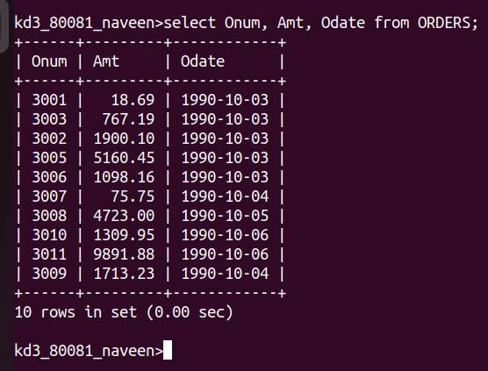
Ques2: Write a query that produces all rows from the Customers table for which the salesperson’s number is 1001?

Answer:

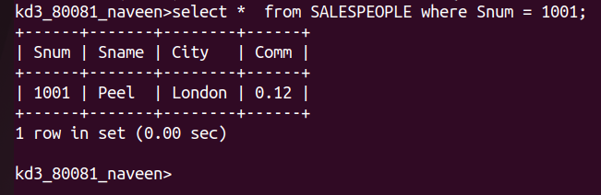

Ques3: Write a query that displays the Salespeople table with the columns in the following order city, sname, snum,comm?
Answer:

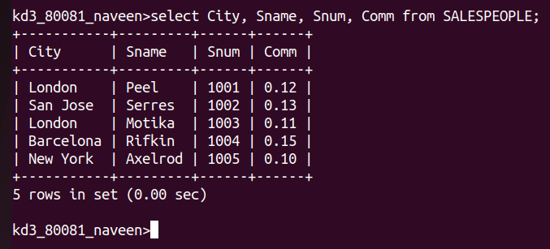

Ques4: Write a select command that produces the rating followed by the name of each customer in San Jose?
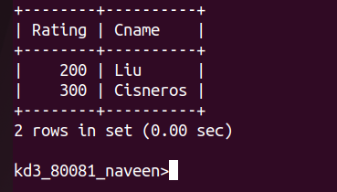
Answer:

